**Data Analysis Report**

**Introduction**

This report presents the findings of a data analysis conducted to address various business questions related to product popularity, customer behavior, sales distribution by time of day, the impact of seasonal discounts, and the influence of customer demographics on sales. The analysis is based on the generated sales data of Blossom flower shop.

**Product Popularity Analysis**

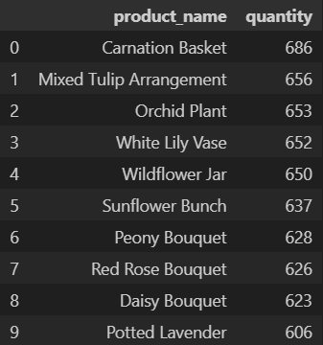**1. Top Selling Products**

**Figure 1**

The analysis reveals that the top selling products in the sales data are as follows:

- Carnation Basket

- Mixed Tulip Arrangement

- Orchid Plant

- White Lily Vase

- Wildflower Jar

These products have consistently high sales volume, indicating their popularity among customers.

**2. Consistently Well-performing Products**

The products that consistently perform well throughout the year include:

- Carnation Basket

- Orchid Plant

- White Lily Vase

These products maintain steady sales figures across different seasons, suggesting a stable demand regardless of the time of year.

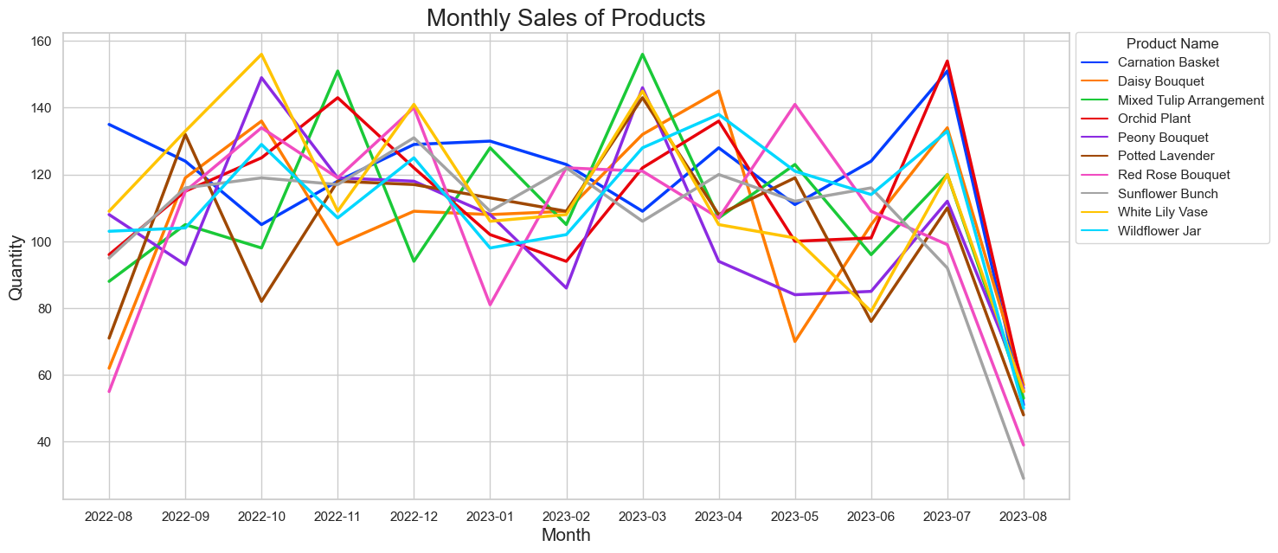

Figure

**Customer Behaviour Insights**

**3. Average Number of Products Purchased**

The average number of products purchased per customer order is approximately 3.9. This indicates that customers tend to buy a variety of products in a single order, contributing to higher sales revenue.

**Sales Distribution by Time of Day**

**4. Peak Purchase Times**

The analysis identifies two specific times of the day when customers frequently make purchases: 20:55:00 and 17:54:10. These times likely correspond to the evening and the start of the night/dinner hours, respectively.

**5. High Sales Activity Time**

The two peak purchase times mentioned above, 20:55:00 and 17:54:10, are associated with higher sales activity. This pattern can be explained by customers purchasing flowers for dinner plans or special occasions, as well as individuals buying flowers on their way back from work to surprise their partners or parents.

**Seasonal Discount Impact**

**6. Effect of Holiday Dates and Special Occasions**

The analysis indicates that sales on Christmas Day and New Year's Day are lower compared to the average daily sales. Specifically, sales on Christmas Day are only 40, while sales on New Year's Day are 27. On regular days, the average sales figure is 39. This suggests that holiday dates and special occasions might not have a significant impact on sales for this flower shop.

**Customer Demographics Influence**

**7. Age Group Contribution to Sales**

The analysis reveals that the age group of 50-69 (2 age groups) contributes significantly more to sales compared to the other age groups. The total sales amount generated by this age group represents approximately 54.9% of the overall sales. In contrast, the combined total sales of the age groups 18-49 (4 age groups) account for approximately 60.3% of the total sales. These findings emphasize that the older demographic holds a stronger influence on the overall sales distribution.

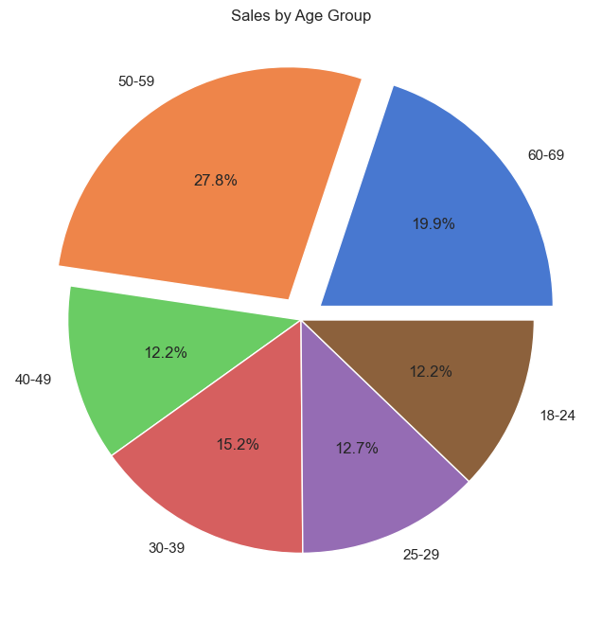

Figure

**8. Age Group Preferences for Products**

The analysis suggests that customers within the age groups 18-25, 25-30, and 40-50 have similar purchase quantities, which are lower compared to other age groups. In contrast, customers in the age group 50-69 exhibit a higher purchase volume, making them a significant segment of the customer base. This implies that products should be tailored to cater to the preferences of the older age group, as they contribute significantly to sales.

Figure

**Recommendations**

The analysis clearly reveals that the majority of customers and sales originate from older age groups. To attract younger customers, the introduction of contemporary products is necessary. Additionally, ensuring affordability for products aimed at younger demographics can lead to a more substantial contribution to sales. Offering student discounts and enhancing packaging with popular aesthetic items like keychains and stickers may further appeal to younger students.

The analysis highlights that sales during holiday dates or special occasions do not significantly differ from those on average days. Therefore, strategizing with sales on specific products and marketing those sales a few days ahead of the occasion could bolster sales during such times.

Implementing a Customer Loyalty program with discounted offerings has the potential to bolster customer retention while also enhancing the precision of analytical insights. This initiative would distinguish the shop from its competitors within the local area. Additionally, incorporating referral bonus points for holders of the Customer Loyalty Program can incentivize the acquisition of new customers, thus fostering an eventual increase in sales.

The combination of high-performing products with their lower-performing counterparts is an approach that may enhance the sales of the latter category. This strategy could not only elevate the sales of these products but also potentially augment the average daily product sales.

**Conclusion**

In conclusion, this data analysis provides valuable insights into product popularity, customer behavior, sales distribution by time of day, seasonal discount impact, and the influence of customer demographics on sales for the flower shop. The findings can guide strategic decisions in terms of product offerings, marketing campaigns, and customer engagement strategies to optimize sales and enhance customer satisfaction.